Michigan State University Extension
Public Policy Brief

Michigan Open Meeting Act Decision Tree
Original version: January 25, 2007
Last revised: January 25, 2007
This pamphlet is designed to help local officials and citizens answer the following two questions:
1. Is a body, organization, or other meeting subject to the Michigan Open Meeting Act?
2. If so, can part of that open meeting be closed to the public?
The flow chart, or decision tree, which starts on page 2 of this pamphlet, is based on P.A. 267 of 1976, as amended, (Michigan Open Meeting Act, M.C.L. 15.261 et seq.), Michigan Attorney General Opinions, and case law established by Michigan courts.
This is a decision tree. It can be used by starting with the question in the upper left box of page two. Answer each question as it applies to the meeting, group, or organization. To the right, bottom, and sometimes top, of the box is an answer in the form of “yes” or “no” with arrows (➔) leading one to the next box. Then answer the question in the next box, and so on. The boxes in the middle column contain additional information rather than a question.
The first part of the flow chart (page 2) addresses the question if the meeting is subject to the Open Meeting Act. If it is, that means the meeting must be posted, (M.C.L. 12.264 and 15.265) and one must provide a subscription for mailing notices to those requesting them (M.C.L. 15.266), the meeting is held in a location available to the public (M.C.L. 15.263(1)), there is a public comment period provided for during the meeting (M.C.L. 15.263(5)), minutes of the meeting are taken (M.C.L. 15.269), and the draft of the minutes are available to the public within eight business days of the meeting (M.C.L. 15.269(3)). Following the chart is the same information in prose.
The second part of the flow chart (page 6 and 7) present a series of questions to determine if a particular agenda item can be discussed during a closed (to the public) portion of the public meeting. Following the second part of the chart is the same information in prose.
There are some exceptions to the requirement that meetings comply with the Open Meeting Act (M.C.L. 15.263(7-11)). Those details are not covered in this pamphlet.

“I know of no safe depository of the ultimate powers of the society but the people themselves . . . and if . . . not enlightened enough to exercise their control
. . . the remedy is . . . to inform their discretion.”
Thomas Jefferson
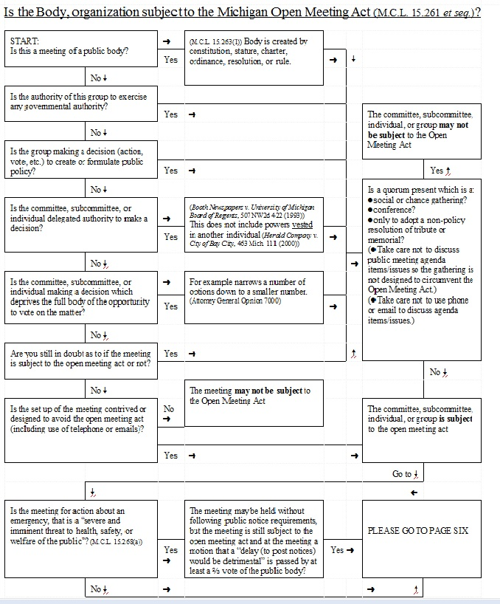

This is a fact sheet developed by experts on the topic(s) covered within MSU Extension. Its intent and use is to assist Michigan communities making public policy decisions on these issues. This work refers to university-based peer reviewed research, when available and conclusive, and based on the parameters of the law as it relates to the topic(s) in Michigan. This document is written for use in Michigan and is based only on Michigan law and statute. One should not assume the concepts and rules for zoning or other regulation by Michigan municipalities and counties apply in other states. In most cases they do not. This is not original research or a study proposing new findings or conclusions.

Contents
(Insert Title) 1
Authors 4

Is the Body, organization subject to the Michigan Open Meeting Act (M.C.L. 15.261 et seq.)?
1.A. Is this a meeting of a public body?
Yes: Go to 2.A.
No: Go to 1.B.

1.B. Is the authority of this group to exercise any governmental authority?
Yes: Go to 3.A.
No: Go to 1.C.

1.C. Is the group making a decision (action, vote, etc.) to create or formulate public policy?
Yes: Go to 3.A.
No: Go to 1.D.

1.D. Is the committee, subcommittee, or individual delegated authority to make a decision?
Yes: Go to 2.B.
No: Go to 1.E.

1.E. Is the committee, subcommittee, or individual making a decision which deprives the full body of the opportunity to vote on the matter? For example narrows a number of options down to a smaller number. (Attorney General Opinion 7000)
Yes: Go to3.A.
No: Go to 1.F.

1.F. Are you still in doubt as to if the meeting is subject to the open meeting act or not?
Yes: Go to 3.A
No: Go to 1.G.

1.G. Is the setup of the meeting contrived or designed to avoid the open meeting act (including use of telephone or emails)?
Yes: Go to 3.C.
No: Go to 2.C.

2.A. (M.C.L. 15.263(1)) Body is created by constitution, stature, charter, ordinance, resolution, or rule. Go to 3.A.

2.B. (Booth Newspapers v. University of Michigan Board of Regents, 507 NW2d 422 (1993)) This does not include powers vested in another individual (Herald Company v. City of Bay City, 463 Mich. 111 (2000))
This applies: Go to 3.A.
Does not apply: Go to 1.E.

2.C. The meeting may not be subject to the Open Meeting Act. End.

3.A. Is a quorum present which is a:
●social or chance gathering?
●conference?
●only to adopt a non-policy resolution of tribute or memorial?
(●Take care not to discuss public meeting agenda items/issues so the gathering is not designed to circumvent the Open Meeting Act.)
(●Take care not to use phone or email to discuss agenda items/issues.)
This applies: Go to 3.B.
Does not apply: Go to 3.C.

3.B. The committee, subcommittee, individual, or group may not be subject to the Open Meeting Act. End.

3.C. The committee, subcommittee, individual, or group is subject to the open meeting act. Go to 4.A.

4.A. Is the meeting for action about an emergency that is a “severe and imminent threat to health, safety, or welfare of the public”? (M.C.L. 15.268(a))
Yes: Go to 4.B.
No: Go to 5.A.

4.B The meeting may be held without following public notice requirements, but the meeting is still subject to the open meeting act and at the meeting a motion that a “delay (to post notices) would be detrimental” is passed by at least a ⅔ vote of the public body? End

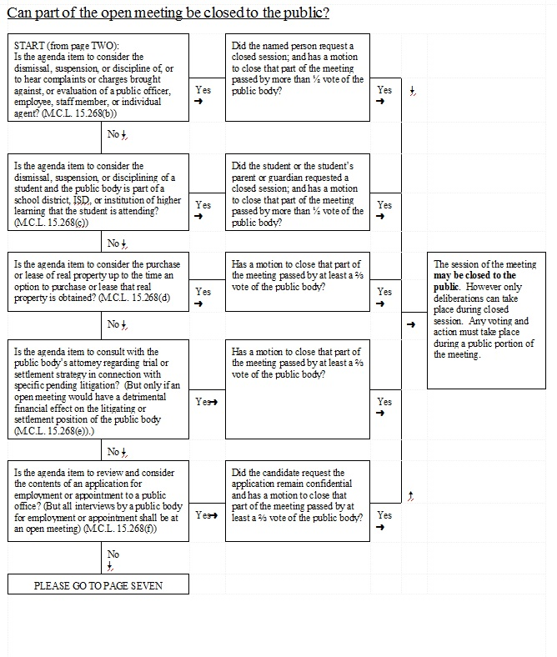

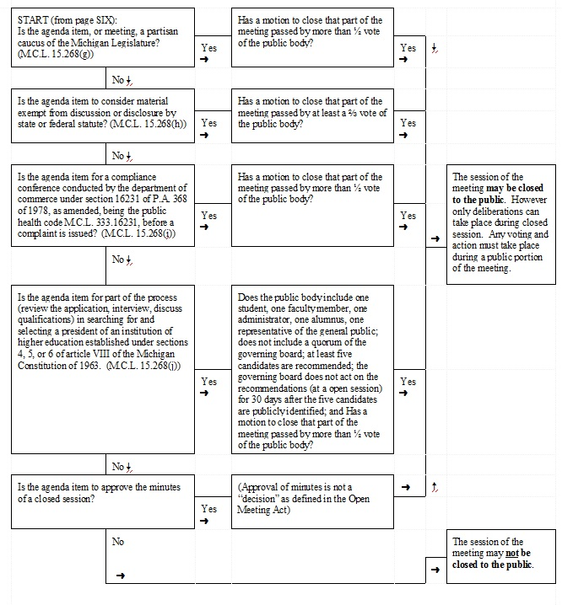

Can part of the open meeting be closed to the public?
5.A Is the agenda item to consider the dismissal, suspension, or discipline of, or to hear complaints or charges brought against, or evaluation of a public officer, employee, staff member, or individual agent? (M.C.L. 15.268(b))
Yes: Go to 6A.
No: Go to 5.B.

5.B. Is the agenda item to consider the dismissal, suspension, or disciplining of a student and the public body is part of a school district, ISD, or institution of higher learning that the student is attending? (M.C.L. 15.268(c))
Yes: Go to 6.B.
No: Go to 5.C.

5.C. Is the agenda item to consider the purchase or lease of real property up to the time an option to purchase or lease that real property is obtained? (M.C.L. 15.268(d)
Yes: Go to 6.C.
No: Go to 5.D.

5.D. Is the agenda item to consult with the public body’s attorney regarding trial or settlement strategy in connection with specific pending litigation? (But only if an open meeting would have a detrimental financial effect on the litigating or settlement position of the public body (M.C.L. 15.268(e)).)
Yes: Go to 6.D.
No: Go to 5.E.

5.E. Is the agenda item to review and consider the contents of an application for employment or appointment to a public office? (But all interviews by a public body for employment or appointment shall be at an open meeting) (M.C.L. 15.268(f))
Yes: Go to 6.E.
No: Go to 5.F.

5.F. Is the agenda item, or meeting, a partisan caucus of the Michigan Legislature? (M.C.L. 15.268(g))
Yes: Go to 6.F.
No: Go to 5.G.

5.G. Is the agenda item to consider material exempt from discussion or disclosure by state or federal statute? (M.C.L. 15.268(h))
Yes: Go to 6.G.
No: Go to 5.H.

5.H. Is the agenda item for a compliance conference conducted by the department of commerce under section 16231 of P.A. 368 of 1978, as amended, being the public health code M.C.L. 333.16231, before a complaint is issued? (M.C.L. 15.268(i))
Yes: Go to 6.H.
No: Go to 5.I.

5.I. Is the agenda item for part of the process (review the application, interview, discuss qualifications) in searching for and selecting a president of an institution of higher education established under sections 4, 5, or 6 of article VIII of the Michigan Constitution of 1963. (M.C.L. 15.268(j))
Yes: Go to 6.I.
No: Go to 5.J.

5.J. Is the agenda item to approve the minutes of a closed session? (Approval of minutes is not a “decision” as defined in the Open Meeting Act)
Yes: Go to 7.A.
No: Go to 7.B.
6.A. Did the named person request a closed session; and has a motion to close that part of the meeting passed by more than ½ vote of the public body?
Yes: Go to 7.A.
No. Go to 5.B.

6.B. Did the student or the student’s parent or guardian requested a closed session; and has a motion to close that part of the meeting passed by more than ½ vote of the public body?
Yes: Go to 7.A.
No. Go to 5.C.

6.C. Has a motion to close that part of the meeting passed by at least a ⅔ vote of the public body?
Yes: Go to 7.A.
No. Go to 5.D.

6.D. Has a motion to close that part of the meeting passed by at least a ⅔ vote of the public body?
Yes: Go to 7.A.
No. Go to 5.E.

6.E. Did the candidate request the application remain confidential and has a motion to close that part of the meeting passed by at least a ⅔ vote of the public body?
Yes: Go to 7.A.
No. Go to 5.F.

6.F. Has a motion to close that part of the meeting passed by more than ½ vote of the public body?
Yes: Go to 7.A.
No. Go to 5.G.

6.G. Has a motion to close that part of the meeting passed by at least a ⅔ vote of the public body?
Yes: Go to 7.A.
No. Go to 5.H.

6.H. Has a motion to close that part of the meeting passed by more than ½ vote of the public body?
Yes: Go to 7.A.
No. Go to 5.I

6.I. Does the public body include one student, one faculty member, one administrator, one alumnus, one representative of the general public; does not include a quorum of the governing board; at least five candidates are recommended; the governing board does not act on the recommendations (at a open session) for 30 days after the five candidates are publicly identified; and Has a motion to close that part of the meeting passed by more than ½ vote of the public body?
Yes: Go to 7.A.
No. Go to 5.J.

7.A. The session of the meeting may be closed to the public. However only deliberations can take place during closed session. Any voting and action must take place during a public portion of the meeting. End.

7.B. The session of the meeting may not be closed to the public. End.

Authors
This publication was developed in collaboration by:
- Kurt H. Schindler, Distinguished Senior Educator Emeritus, MSU Extension, Michigan State University
- John Amrhein, Educator, MSU Extension, Michigan State University
Contributors:
- Elizabeth More, Policy Education Specialist Emeritus

To find contact information for authors or other MSU Extension experts use this web page: http://msue.anr.msu.edu/experts.
MSU is an affirmative-action, equal-opportunity employer, committed to achieving excellence through a diverse workforce and inclusive culture that encourages all people to reach their full potential. Michigan State University Extension programs and materials are open to all without regard to race, color, national origin, gender, gender identity, religion, age, height, weight, disability, political beliefs, sexual orientation, marital status, family status or veteran status. Issued in furtherance of MSU Extension work, acts of May 8 and June 30, 1914, in cooperation with the U.S. Department of Agriculture. Jeffrey W. Dwyer, Director, MSU Extension, East Lansing, MI 48824. This information is for educational purposes only. Reference to commercial products or trade names does not imply endorsement by MSU Extension or bias against those not mentioned. The name 4-H and the emblem consisting of a four-leaf clover with stem and the H on each leaflet are protected under Title 18 USC 707.

