
Open your home to the world – host an Academic Year student with States’ 4-H International!
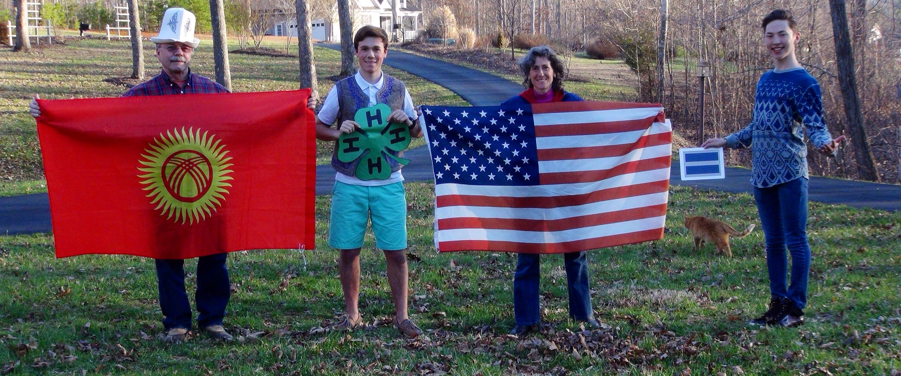


What makes States’ 4-H International different?
When you host with us, you partner with one of the largest youth-serving organizations in America. 4-H is built on a model of positive youth development.

We see hosting as an educational opportunity not just for the exchange student, but also for the host family, host school, and entire host community. S4-H programs focus on life skill development, including communication, tolerance, respect for others, and engaged citizenship.

Our vast and multi-layered support network means there is always someone available to help if you have a question, problem, or just need advice on how to handle a particular situation!

Go to http://www.states4hexchange.org/year-long/ to see available students.

For application materials:
http://4h.msue.msu.edu/programs/international_exchange_programs

For more information, contact:
Jan Brinn, Allegan County MSU Extension Office
269-673-0370 Ext. 2555
brinn@anr.msu.edu

