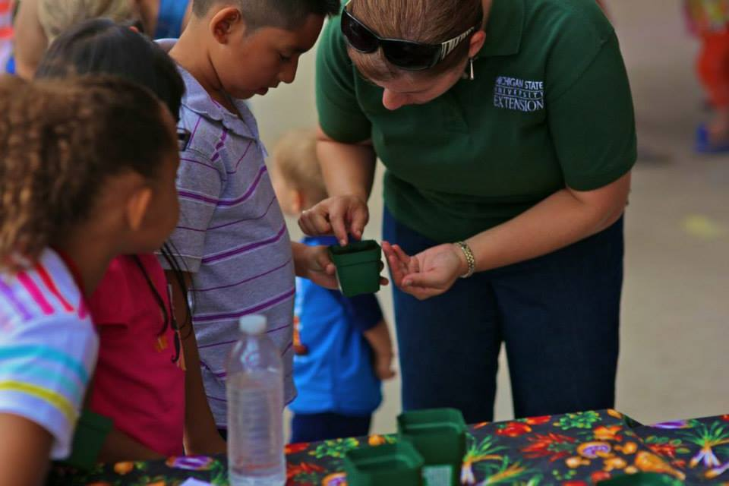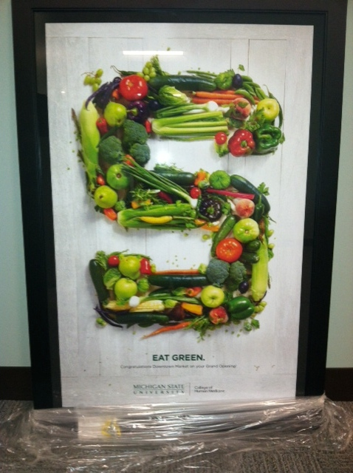

* Launched a media campaign that ran from July-September with WZZM and the Grand Rapids Community Foundation to promote the Downtown Market and produce donation to food pantries. Connection with GVSU and Heartside Gleaning Initiative.
* Expanding MSU Extension’s Michigan Fresh campaign through social media and new fact sheet development.
* Sponsoring the inaugural Michigan Harvest Ale tasting event on December 9 to coincide with the Great Lakes Fruit and Vegetable Expo.
* Working with local schools and hospitals to source local: asparagus, blueberries, tomatoes, and apples through CultivateMichigan.org
* Assisting in the coordination of Arts and Eats, an event on Oct. 18-19, 2014 to promote farmers markets, restaurants and artisans in Allegan and Barry County. Developing community partnerships to grow the event.

You can receive monthly e-newsletters about local food research, news and events by joining our mailing list at www.msue.anr.msu.edu Visit www.mi.foodmarketmaker.com to find a local farmers market or food business near you! *MSU is an affirmative-action, equal-opportunity employer.  Michigan State University Extension programs and materials are open to all without regard to race, color, national origin, gender, gender identity, religion, age, height, weight, disability, political beliefs, sexual orientation, marital status, family status or veteran status.*

Also!

# Current

# Projects

“Making It In Michigan” conference and marketplace trade show at the Lansing Center.

“Cottage to Commercial” workshop at the Muskegon MSU Extension office. Basic food processing, licensing, business planning for food businesses. $20.00

Oct. 28

Michigan Good Food Summit in Lansing, MI

MSU Extension at the Downtown Market

Kendra Wills , Community Food Systems Educator Tel: (616) 608-7424 willsk@anr.msu.edu Areas of focus: Farm-to-School, Student Intern Supervisor, Social Media, Produce Donation Campaign, Local Food Events

Garrett Ziegler, Community Food Systems Educator Tel: (616) 608-7436 zieglerg@anr.msu.edu Areas of focus: Food Hub Development, Farm-to-Health Care, Cultivate Michigan Campaign, Culinary Tourism

Kay Cummings MSU Product Center Innovation Counselor (231) 750-2772 cummin13@anr.msu.edu Areas of focus: food product development for retail markets, business plan development, packaging and labeling assistance.

## Upcoming Events

#MSUEFoodIsArt Instagram contest. Submit photos and win prizes!

Sept. 24 – Oct 12

Oct. 1

Nov. 12

#### Like MSU Extension at the Downtown Market on Facebook.

Fall 2014

www.msue.anr.msu.edu