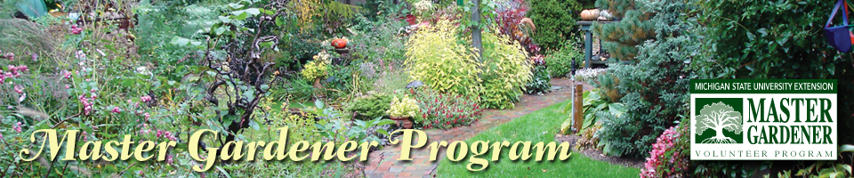**Become A Master Gardener!**

Michigan State University Extension’s Master Gardener Program

**Harper Woods, MICHIGAN**

**August 23 – November 22, 2016**

**Classes every Tuesday, 6:00 pm – 10:00 pm**

Wayne County Community College District

Auditorium

19305 Vernier

Harper Woods, MI  48225

The cost of the 14-week program is $300, which includes the 1,000-page training manual.

**Gain Access to World Class Gardening Knowledge.** The 14-session curriculum will provide horticulture training based on university research. This training consists of approximately 45 hours of training with classes on

* Plant science
* Soil science
* Integrated pest management
* Diagnostics
* Annuals and Perennials
* Woody ornamentals
* Lawns
* Vegetables
* Small fruits
* Tree fruits
* Household and nuisance pests
* Gardening practices to protect water quality

**Have An Opportunity to Serve.** After completing the training, Master Gardener Certification is achieved with completion of 40 hoursof horticulture-related volunteer service. Examples of volunteer projects and service may include: designing a school garden, designing and caring for gardens at senior centers, parks and other public sites, teaching others how to garden, establishing vegetable gardens to meet local nutritional needs, and/or beautifying community sites.

**Registration Deadline August 12, 2016**

To enroll in the Master Gardening training, please complete the registration and agreement forms online at [**http://events.anr.msu.edu/harperwoods16/**](http://events.anr.msu.edu/harperwoods16/)**.**

**Questions?**

Deirdre Hope at [hopedeir@anr.msu.edu](mailto:hopedeir@anr.msu.edu) or 734.546.8657