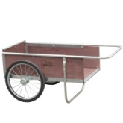 Help Restock the Giving Garden Shed! 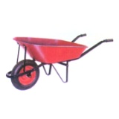
There was a theft at the Giving Garden recently and a variety of items was stolen. Sheriff's deputy suspects the items were stolen for quick sale for cash for illegal purchases (i.e. drugs).
Your help is welcomed as we try to restock what was stolen from the Giving Garden. You may donate used items on the list below or donate money that will be used to replace the stolen items: Two cycle rototiller
Screwdrivers, flat head & phillips head
Wire cutters
Pliers
Two 3# mauls
100' tape measure
Gas can
Wooden ramps for driving equipment in/out of shed
Garden hoses (100' long)
2 water spigots
1 garden cart
1 wheelbarrow
Obnoxiously bright paint to spray handles
Solar motion sensor lights (2)
Video camera for outdoor use (non-functioning)
Key lock sets for shed doors
Donations already received:
MG who will engrave all equipment and tools
Tool box
Items may be dropped off at the MSUE office, 3299 Gull Road, Wing 2, Room 410. If you would like to make a $ donation please make check payable to KCMGA Program, and send to: MSUE, PO Box 42, Nazareth, MI 49074-0042. Gifts are tax deductible.

