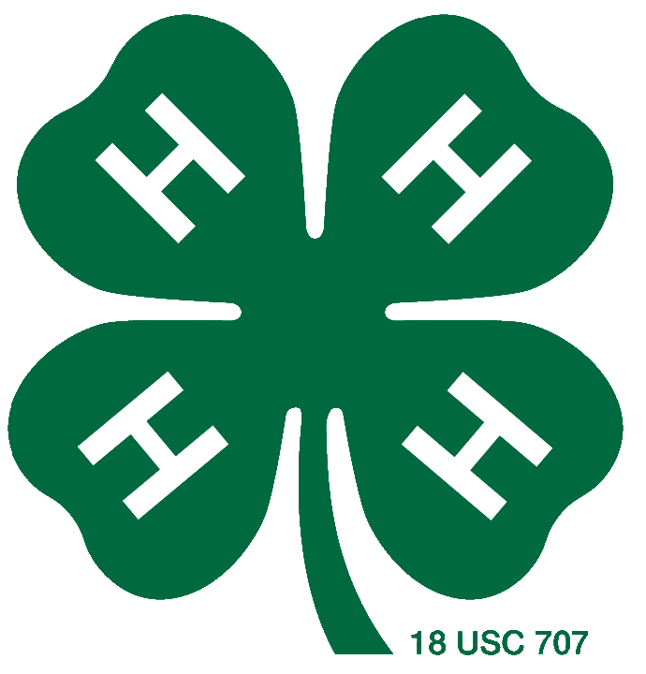2017 Oceana County 4-H Ambassador Application
Name: _______________________________________________________
Address: _____________________________________________________
City: ___________________________ Zip: _______________________
Home Phone: ____________________ Cell Phone: ________________
Email Address: ________________________________________________
Birth Date: _________________ ______ Grade in School: ____________
Name of School: _______________________________________________
Age (as of Aug. 1st, 2017): ______ ____ Years in 4-H: ________________
Name of 4-H Club(s): ____________________________________________
Basic Requirements
A 4-H member who is eligible has:
- Reached 13 years of age by August 1st of the current year.
- Completed 2 calendar years of club work by August 31st, 2017.
- Completed the enclosed 4-H Achievement Summary. Return to the Oceana County MSU Extension Office by 5:00 p.m. Friday, July 21, 2017
- Familiarized themselves with the 4-H philosophy, pledge and motto. http://4h.msue.msu.edu/about/mi_4h_FAQS
- Participated in club and county 4-H opportunities that promote 4-H to others.
- Given to their community through service.
- Demonstrated leadership skill development through their involvement in 4-H.
Required Availability
- Attend an interview session at the Oceana County MSU Extension Office on Tuesday, August 1st, time to be determined.
- Attend the presentation of Ambassadors Tuesday, August 22nd at 5:30 pm prior to the Draft Show in the arena at the Oceana County Fairgrounds.
- Attend the Large Animal Auction Thursday, August 24th at 6:45pm to be photographed for the newspaper and Extension archives and lead the American and 4-H pledges. Lead pledges at the Small/Junior Auction Saturday, August 26th at 5:00 pm.
- Willingness to represent 4-H through duties assigned during the year, including during the week of Fair 2017.
Biography
Write a summary about yourself and your 4-H involvement that will be used to introduce you prior to the Large Animal Auction Thursday night (Maximum 200 words).

Identify a 4-H leadership experience you have had and describe its significance to your personal growth and development.

Identify a 4-H citizenship/community service experience you have had and describe its significance to you and your community.

4-H Project Summary
Project Name No. Years Leadership/Service Contributions through Project
Enrolled
Example: Pig | 5 | Big Buddy 3 yrs, planned 2 clinics for club, organized club walking in Asparagus Parade, spoke about 4-H and my pig to 4th grade class
List of 4-H Experiences
I have held the following offices in 4-H clubs:
Officer Role | Number of Years | Club

List Oceana County 4-H involvement (Youth Council meetings, Livestock Committee membership, Folk Festival volunteer, Yard Sale volunteer, Adopt-a-Highway Pick-up, etc):

List examples of knowledge/skill development across multiple project areas (Grand Slam competition, attending other species club meetings, membership in multiple clubs, etc.):

I have attended (list dates)
Exploration Days:

Kettunen Center Workshops:

Other State 4-H Events:

Special 4-H Awards Received (including Oceana County 4-H Fall Awards):

Other Activities Summary
List accomplishments other than 4-H you have attained: church, school, athletics, other youth organizations, etc.:

Signed: ______________________________ Date: _____________

