Exhibitor #

__________________
2015 – 2016
EMMET – CHARLEVOIX COUNTY
4-H MARKET LIVESTOCK ASSOCIATION
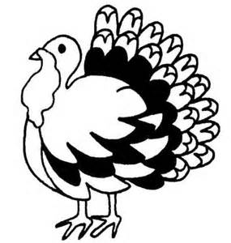
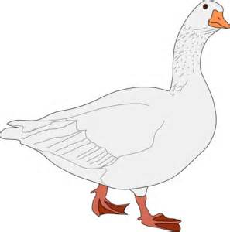
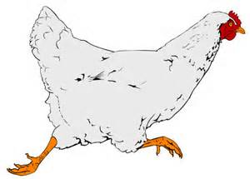
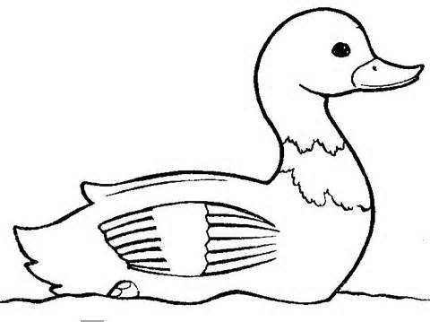

INTERMEDIATE RECORDS

NAME __________________________________________________________________

CLASS: INTERMEDIATE (12-14 yrs) 4-H AGE_______________________

SPECIES: CHICKENS[ ] TURKEYS [ ] GEESE [ ] RABBITS [ ] DUCKS [ ]

City _________________________________________________________________
Club Name _________________________________________________________________
Club Leader _________________________________________________________________
County __________________________________________________________________

Book updated:
January 1, 2016
Page 1
Market Livestock Record Book Intermediate

Records are due from 12:00 NOON to 6 p.m. on the first Sunday of the Fair. Books are to be turned in at the Community Center check-in station after they have been signed by your leader.

PLEASE TYPE, PRINT, OR WRITE CLEARLY.

WHY KEEP RECORDS?

By keeping records, you will be able to see how much progress you make as you set goals and work to accomplish them.

Good records will:
- help you learn about animals, their rate of growth, the feed they require, and their habits,
- help you understand your project’s financial outcome,
- improve your management practices,
- give you a record of your project activities,
- help you plan future projects.

This record for intermediate animal projects is a required part of your project and entry into the Emmet-Charlevoix County 4-H Market Livestock shows and sale. You need to submit one record book for each of the market livestock projects you participate in. The record book needs to be completed by the exhibitor.

If you have questions or need help on this record book, please contact your leader, parent/guardian, or County MSU Extension Office.

This record book has been completed to the best of my ability.

_______________________________________
Exhibitor’s Signature

_______________________________________
Parent / Guardian Signature

________________________________________
Leader’s Signature

Comments by Leader / Parent (optional):__________________________________________

______________________________________________________________________________

______________________________________________________________________________

Page 2
Market Livestock Record Book – Intermediate

WEIGHT RECORD

 | Date | Weight | Date | Weight | Date | Weight | Date | Weight
April
May
June
July
August

Final Weight
you’ll need to transfer this number
to pages 4, 7 & 8)

Total pounds of gain
(You’ll need to transfer this number
to pages 4 & 8

Page 3
Market Livestock Record Book – Intermediate

WEIGHT RECORD - A bimonthly weight record is useful when comparing weight gained by the animal to the amount of feed fed that animal in the same month.
A B C D
 | Date | Weight | Weight Gain (subtract current from previous weight) | Days On Feed | Average Daily Gain  (weight gain divided by days on feed) | Remarks ( include how weight was determined, by tape or scale)
1 |  |  |  | STARTING WEIGHT
2 |  |  | (A2 - A1) |  | (B2 ÷ C2)
3 |  |  | (A3 - A2) |  | (B3 ÷ C3)
4 |  |  | (A4 – A3) |  | (B4 ÷ C4)
5 |  |  | (A5 – A4) |  | (B5 ÷ C5)
6 |  |  | (A6 – A5) |  | (B6 ÷ C6)
7 |  |  | (A7 – A6) |  | (B7 ÷ C7)
8 |  |  | (A8 – A7) |  | (B8 ÷ C8)
9 |  |  | (A9 – A8) |  | (B9 ÷ C9)
10 |  |  | (A10 – A9) |  | (B10 ÷ C10)
FINAL WEIGHT**  (A12) |  |  | DAYS ON FEED (add column C)

________________ --- ___________________ = ___________________
FINAL WEIGHT STARTING WEIGHT TOTAL LBS of GAIN
Total gain determination

Page 4
Market Livestock Record Book – Intermediate
 | MONTHLY FEED RECORD WORKSHEET
Feed Types⇒
 | lbs. | cost | lbs. | cost | lbs. | cost | lbs. | cost | Monthly  lbs. | Total  Cost
APRIL

MAY

JUNE

JULY

AUG

TOTALS |  |  |  |  |  |  |  |  |  | $
TOTAL FEED
add column

TOTAL FEED COST add column

NOTE: RECORD FEED AS IT IS FED TO YOUR ANIMAL. Type of feed should include: grains, supplements, mixes, hay, silage, etc. The value of homegrown feed needs to be included.

Page 5
Market Livestock Record Book – Intermediate

EXPENSES OTHER THAN FEED WORKSHEET

MONTHLY
TOTAL

APR |  |  |  |  |  |  |  |  |  |  | $
MAY |  |  |  |  |  |  |  |  |  |  | $
JUNE |  |  |  |  |  |  |  |  |  |  | $
JULY |  |  |  |  |  |  |  |  |  |  | $
AUG |  |  |  |  |  |  |  |  |  |  | $
TOTALS |  |  |  |  |  |  |  |  |  |  | TOTAL  $

Page 6
Market Livestock Record Book – Intermediate

PROJECT ANIMAL:
Leg band No's or Tattoo No's | Sex | Breed | Date  Acquired | Value of Animal/ Purchase Price

FINANCIAL SUMMARY
Fill in the following to determine the net income from your project (that is, money you have earned for your time, management and financial investment).

INCOME AND VALUE AT CLOSE OF RECORD:

______________ X ________________ = $____________
Market Price* Final Weight Expected Income

Other income (if any, specify) ____________________________ $__________
Total Expected Income (add expected income and other income)
$_________

*Market Price - is the price you would receive under normal sale conditions (such as an auction sale yard). These prices are published in agricultural newspapers, magazines, or TV and radio farm reports, and the Internet.

EXPENSES AND VALUE AT START OF RECORD:

_____________ + ___________ + _______________ = $______________
Value of animal Feed Cost Other Expenses Total Expenses
(from above) (page 5) (page 6)
Total Expenses
$_________________

Net profit (or loss) - Total expected income minus total expenses
A net loss does not necessarily mean you did a poor job with your project.

________________ - ______________ = $______________
Total Expected Total Expenses Net Profit / or loss
Income

Page 7
Market Livestock Record Book – Intermediate

PROJECT EFFICIENCY INFORMATION

Start Weight (A1 pg 4) ___________ Days on Feed (Total of Column C pg 4) ____________

Final Weight (A12 pg 4) _________ Total lbs of Gain (pg 4) ________________

Total Feed (pg 5) ________________ Total Feed Cost (pg 5) ________________________

Total Expenses (pg 7) _________________

Average Daily Gain

__________ ÷ ___________ = _____________
Total lbs of # Days on Average Daily
Gain Feed Gain

Feed Cost per Pound of Gain

$_________ ÷ ___________ = $_________
Total Feed Total lbs. Feed Cost per
Cost of Gain lb. of Gain

FORMULA TO CALCULATE YOUR BREAKEVEN PRICE

__________ ÷ ___________ = $_____________
Total Final Weight Breakeven Price -
Expenses of Animal Needed to Cover Expenses

Page 8
Market Livestock Record Book – Intermediate

PROJECT PICTURES

Taking a picture of your project animal at the beginning and at the end of your project will indicate how your animal has grown and developed. Use this page to display your beginning and end of project pictures. Add additional photos!

DATE OF BEGINNING PHOTO _______________

DATE OF ENDING PHOTO _______________

Page 9
Market Livestock Record Book – Intermediate

PROJECT NARRATIVE: In the narrative, please respond to the following (additional pages can be added). Each question is worth 10 points for a possible score of 50.

1. Describe the positive and negative effects of having corn or feed containing corn in your rations.

____________________________________________________________________________________________________

____________________________________________________________________________________________________

____________________________________________________________________________________________________

____________________________________________________________________________________________________

____________________________________________________________________________________________________

____________________________________________________________________________________________________

2. Besides the Market Livestock sale, what would be some other marketing alternatives for your animal? Which would be the best alternative and why?

____________________________________________________________________________________________________

____________________________________________________________________________________________________

____________________________________________________________________________________________________

____________________________________________________________________________________________________

____________________________________________________________________________________________________

3. Analyze your daily gain records. Analyze your feed records. What conclusions can you arrive at by comparing the two records? List and explain what factors have influenced your average daily gain.

____________________________________________________________________________________________________

____________________________________________________________________________________________________

____________________________________________________________________________________________________

____________________________________________________________________________________________________

____________________________________________________________________________________________________

Page 10
Market Livestock Record Book – Intermediate
4. An animal’s conformation does not meet what the judges want. Describe two ethical practices that could be used to affect the animal’s conformation.

____________________________________________________________________________________________________

____________________________________________________________________________________________________

____________________________________________________________________________________________________

____________________________________________________________________________________________________

____________________________________________________________________________________________________

5. What methods and practices did you or can you use to influence your animal’s daily gain?

____________________________________________________________________________________________________

____________________________________________________________________________________________________

____________________________________________________________________________________________________

____________________________________________________________________________________________________

____________________________________________________________________________________________________

6. What did you learn in the project this year? ___________________________________________________________
____________________________________________________________________________________________________

____________________________________________________________________________________________________

____________________________________________________________________________________________________

____________________________________________________________________________________________________

____________________________________________________________________________________________________

Page 11
Market Livestock Record Book – Intermediate

1MSU is an affirmative-action, equal opportunity employer.
MSU Extension programs and materials are open to all without regard to race, color, gender, gender identity, religion, age, height, weight, disability, political beliefs, sexual orientation, marital status, family status or veteran status.

