Exhibitor #

____________
2015 - 2016
EMMET – CHARLEVOIX COUNTY
4-H MARKET LIVESTOCK ASSOCIATION

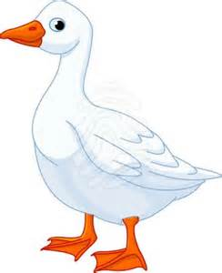
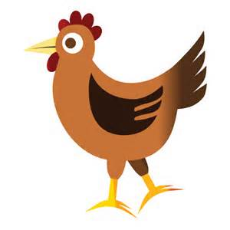
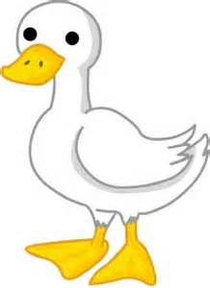
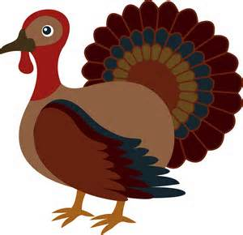

BEGINNER RECORDS

Name: _____________________________________________________________________________

CLASS: BEGINNER (9-11 yrs.) 4-H Age ________________

SPECIE: CHICKENS [ ] TURKEYS [ ] GEESE [ ] RABBITS [ ] DUCKS [ ]

City ______________________________________________________________________________
Club Name ______________________________________________________________________________
Club Leader ______________________________________________________________________________
County ______________________________________________________________________________

Page 1
Book updated:
January 1, 2016
Market Livestock Record Book – Beginner

Records are due from 12:00 noon to 6:00 pm on the first Sunday of the Fair. Books are to be turned in at the Community Center check-in station after they have been signed by your leader.

PLEASE TYPE, PRINT, OR WRITE CLEARLY.

WHY KEEP RECORDS?

By keeping records you will be able to see how much progress you make as you set goals and work to accomplish them.

Good records will:
- help you learn about animals, their rate of growth, the feed they require, the cost of the feed they require, their habits,
- help you understand your project’s financial outcome,
- improve your management practices,
- give you a record of your project activities, and
- help you plan future projects.

This record for beginner animal projects is a required part of your project and entry into the Emmet-Charlevoix County 4-H Market Livestock shows and sale. You need to submit one record book for each of the market livestock projects you participate in. The record book needs to be completed by the exhibitor.

If you have questions or need help on this record book, please contact your leader, parent/guardian, or County MSU Extension Office.

This record book has been completed to the best of my ability.

_______________________________________
Exhibitor’s Signature

_______________________________________
Parent / Guardian Signature

_______________________________________
Leader’s Signature

Comments by Leader / Parent (optional):______________________________________________________

__________________________________________________________________________________________

Page 2
Market Livestock Record Book - Beginner
 | MONTHLY FEED RECORD WORKSHEET
Feed Types⇒
 | lbs. | cost | lbs. | cost | lbs. | cost | lbs. | cost | Monthly  lbs. | Total  Cost
APRIL

MAY

JUNE

JULY

AUG

TOTALS |  |  |  |  |  |  |  |  |  | $
TOTAL FEED
add column

TOTAL FEED COST add column

NOTE: RECORD FEED AS IT IS FED TO YOUR ANIMAL. Type of feed should include: grains, supplements, mixes, hay, silage, etc. The value of homegrown feed needs to be included.

Page 3 - Market Livestock Record Book – Beginner

EXPENSES OTHER THAN FEED WORKSHEET

MONTHLY
TOTAL

APR |  |  |  |  |  |  |  |  |  |  | $
MAY |  |  |  |  |  |  |  |  |  |  | $
JUNE |  |  |  |  |  |  |  |  |  |  | $
JULY |  |  |  |  |  |  |  |  |  |  | $
AUG |  |  |  |  |  |  |  |  |  |  | $
TOTALS |  |  |  |  |  |  |  |  |  |  | TOTAL  $

Page 4
Market Livestock Record Book – Beginner

WEIGHT RECORD

 | Date | Weight | Date | Weight | Date | Weight | Date | Weight
April
May
June
July
August

Final Weight
you’ll need to transfer this number
to pages 4, 7 & 8)

Total pounds of gain
(You’ll need to transfer this number
to pages 4 & 8

Page 5
Market Livestock Record Book – Beginner
THIS IS MY PROJECT ANIMAL:
Leg Band No's or Tattoo No's | Sex | Breed | Date Acquired | Final  Weight

My estimated project income:

______________ X ________________ = $_________________________
Market Price* Final Weight Expected Market Income

*MARKET PRICE - is the price you would receive under normal sale conditions (such as an auction sale yard). These prices are published in agriculture newspapers, magazines, or TV and radio farm reports, and the Internet.

+ $___________________ =
(other income)
Total Expected Income
(add expected market income and other income)

MY PROJECT EXPENSES: VALUE

PURCHASED ANIMAL, PLEASE LIST PRICE, OR RAISED ANIMAL, LIST VALUE AT START OF PROJECT | a $
TOTAL FEED COST FROM MONTHLY  FEED RECORD WORKSHEET pg. 3 | b $
TOTAL COST FROM EXPENSES  OTHER THAN FEED WORKSHEET pg. 4 | c $
TOTAL EXPENSES (a+b+c) | $
Total Expenses
FORMULA TO CALCULATE YOUR BREAKEVEN PRICE

$__________ ÷ __________ = $__________
Total Final Weight Breakeven Price
Expenses of Animal (Needed to Cover Expenses)

Page 6
Market Livestock Record Book - Beginner

PROJECT EFFICIENCY INFORMATION

Start Weight (pg 5) __________ Days on Feed (pg 3) _________

Final Weight (pg 5) _________ Total lbs of Gain (pg 5) _______________________

Total Feed (pg 3) _______________ Total Feed Cost (pg 3) ________________________

Total Expenses (pg 4) _________________

Average Daily Gain

__________ ÷ __________ = _____________
Total lbs of Days on Average Daily
Gain Feed Gain

Feed Cost per Pound of Gain

$_________ ÷ ___________ = $____________
Total Feed Total lbs. Feed Cost per
Cost of Gain lb. of Gain

FORMULA TO CALCULATE YOUR BREAKEVEN PRICE:

_____________ ÷ _____________ = $_______________
Total Final Weight Breakeven Price-
Expenses of Animal (needed to cover expenses)

Page 07
Market Livestock Record Book – Beginner

MY PROJECT PICTURES

Taking a picture of your project animal at the beginning and at the end of your project will indicate how your animals have grown and developed. Use this page to display your beginning and end of project pictures. Please add additional photos.

DATE OF BEGINNING PHOTO _______________

DATE OF ENDING PHOTO ______________

Page 8
Market Livestock Record Book - Beginner
PROJECT NARRATIVE

PROJECT GOALS
(Tell why you enrolled in this project and what you want to do and learn with it this year.)

____________________________________________________________________________________________
____________________________________________________________________________________________
ABOUT MY ANIMAL:
This is how I obtained my animal:_________________________________________________________________
____________________________________________________________________________________________
This is what I do to keep my animal healthy:________________________________________________________
____________________________________________________________________________________________

This is what I feed my animal:____________________________________________________________________
____________________________________________________________________________________________

What did you learn in the project this year? _________________________________________________________

____________________________________________________________________________________________

What did you enjoy most about this project? ________________________________________________________

____________________________________________________________________________________________

What was your biggest challenge? _________________________________________________________________

____________________________________________________________________________________________

Page 9
Market Livestock Record Book – Beginner

1MSU is an affirmative-action, equal opportunity employer.
MSU Extension programs and materials are open to all without regard to race, color, gender, gender identity, religion, age, height, weight, disability, political beliefs, sexual orientation, marital status, family status or veteran status.

