EXHIBITOR #

_____________
2015 - 2016
EMMET-CHARLEVOIX COUNTY
4-H MARKET LIVESTOCK ASSOCIATION
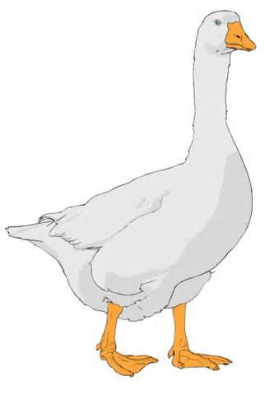

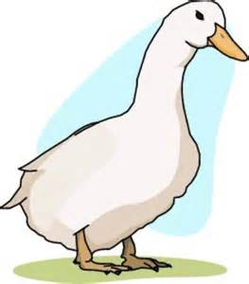
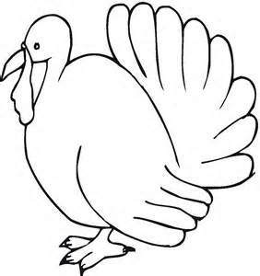
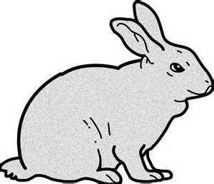
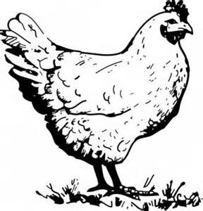

ADVANCED RECORDS

NAME _______________________________________________________________________________

CLASS: ADVANCED (15-19 YRS) 4-H Age: ___________________

SPECIES: CHICKENS [ ] TURKEYS [ ] GEESE [ ] RABBITS [ ] DUCKS [ ]

City _______________________________________________________________________________
Club Name _______________________________________________________________________________
Club Leader _______________________________________________________________________________
County ________________________________________________________________________________

Page 1
Book updated:
January 1, 2016
Market Livestock Record Book – Advanced

Records are due from 12:00 NOON to 6 p.m. on the first Sunday of the Fair. Books are to be turned in at the Community Center check-in station after they have been signed by your leader.

PLEASE TYPE, PRINT, OR WRITE CLEARLY.

WHY KEEP RECORDS?

By keeping records you will be able to see how much progress you make as you set goals and work to accomplish them.

Good records will:
- help you learn about animals, their rate of growth, the feed they require, and their habits,
- help you understand your project’s financial outcome,
- improve your management practices,
- give you a record of your project activities,
- help you plan future projects.

This record for advanced animal project members is a required part of your project and entry into the Emmet-Charlevoix County 4-H Market Livestock Show and Sale. You need to submit one copy of a record book for each of the market livestock projects you participate in. The record book needs to be completed by the exhibitor.

If you have questions or need help on this record book, please contact your leader, parent/guardian, or county MSU Extension Office.

This record book has been completed to the best of my ability.

_______________________________________
Exhibitor’s Signature

_______________________________________
Parent / Guardian Signature

________________________________________
Leader’s Signature

Comments by Leader / Parent (optional):______________________________________________________

_________________________________________________________________________________________

_________________________________________________________________________________________

_________________________________________________________________________________________

Page 2
Market Livestock Record Book – Advanced

WEIGHT RECORD

 | Date | Weight | Date | Weight | Date | Weight | Date | Weight
April
May
June
July
August

Final Weight
you’ll need to transfer this number
to pages 4, 7 & 8)

Total pounds of gain
(You’ll need to transfer this number
to pages 4 & 8

Page 3
Market Livestock Record Book - Advanced

WEIGHT RECORD - A bimonthly weight record is useful when comparing weight gained by the animal to the amount of feed fed that animal in the same month.

A B C D
 | Date | Weight | Weight Gain (subtract current from previous weight) | Days On Feed | Average Daily Gain  (weight gain divided by days on feed) | Remarks ( include how weight was determined, by tape or scale)
1 |  |  |  | STARTING WEIGHT
2
3
4
5
6
7
8
9
10
FINAL WEIGHT**  (A12) |  |  | DAYS ON FEED (add column C)

_____________ --- ________________ = ____ _________
FINAL WEIGHT STARTING WEIGHT TOTAL LBS of GAIN
Total gain determination

Page 4
Market Livestock Record Book – Advanced

 | MONTHLY FEED RECORD WORKSHEET
Feed Types⇒
 | lbs. | cost | lbs. | cost | lbs. | cost | lbs. | cost | Monthly  lbs. | Total  Cost
APRIL

MAY

JUNE

JULY

AUG

TOTALS |  |  |  |  |  |  |  |  |  | $
TOTAL FEED
add column

TOTAL FEED COST add column

NOTE: RECORD FEED AS IT IS FED TO YOUR ANIMAL. Type of feed should include: grains, supplements, mixes, hay, silage, etc. The value of homegrown feed needs to be included.

Page 5
Market Livestock Record Book - Intermediate

EXPENSES OTHER THAN FEED WORKSHEET

MONTHLY
TOTAL

APR |  |  |  |  |  |  |  |  |  |  | $
MAY |  |  |  |  |  |  |  |  |  |  | $
JUNE |  |  |  |  |  |  |  |  |  |  | $
JULY |  |  |  |  |  |  |  |  |  |  | $
AUG |  |  |  |  |  |  |  |  |  |  | $
TOTALS |  |  |  |  |  |  |  |  |  |  | TOTAL  $

Page 6
Market Livestock Record Book - Advanced

PROJECT ANIMAL:
Leg Band No's or Tattoo No's | Sex | Breed | Date  Acquired | Value of Animal/ Purchase Price

FINANCIAL SUMMARY
Fill in the following to determine the net income from your project (that is, money you have earned for your time, management and financial investment).

INCOME AND VALUE AT CLOSE OF RECORD

______________ X ______________ = $____________
Market Price* Final Weight Expected Income

Other income (if any, specify) ____________________________ $__________
Total Expected Income (add expected income and other income)
$_________

*Market Price - is the price you would receive under normal sale conditions (such as an auction sale yard). These prices are published in agricultural newspapers, magazines, or TV and radio farm reports, and the Internet.

EXPENSES AND VALUE AT START OF RECORD:

_____________ + ___________ + _____________ = $____________
Value of animal Feed Cost Other Expenses Total Expenses
(from above) (page 5) (page 6)
Total Expenses
$_________

Net profit (or loss) - Total expected income minus total expenses
A net loss does not necessarily mean you did a poor job with your project.

____________ - _________ = $ ______________
Total Expected Total Net Profit / or loss
Income Expenses

Page 7
Market Livestock Record Book – Advanced

PROJECT EFFICIENCY INFORMATION

Start Weight (A1 pg 4) __________ Days on Feed (Total of Column C pg 4) _________

Final Weight (A12 pg 4) _________ Total lbs of Gain (pg 4) _______

Total lbs Feed (pg 5) _______________ Total Feed Cost (pg 5) __________________

Total Expenses (pg 7) ___________

Average Daily Gain

__________ ÷ _____________ = ________________
Total lbs of Days on Feed Average Daily Gain
Gain

Feed Cost per Pound of Gain

$_________ ÷ ___________ = $_________
Total Feed Total lbs. Feed Cost per
Cost of Gain lb. of Gain

Pounds of Feed per Pounds of Gain

_____________ ÷ ___________ = _______________
Total lbs. of Total lbs. Lbs. of feed fed
feed fed of gain per lb. of gain

FORMULA TO CALCULATE YOUR BREAKEVEN PRICE

__________ ÷ ____________ = $_________________
Total Final Weight Breakeven Price
Expenses of Animal (Needed to Cover Expenses)

Page 8
Market Livestock Record Book – Advanced

PROJECT PICTURES

Taking a picture of your project animal at the beginning and at the end of your project will indicate how your animal has grown and developed. Use this page to display your beginning and end of project pictures. Add additional photos!

DATE OF BEGINNING PHOTO ____________________

DATE OF ENDING PHOTO _______________

Page 9
Market Livestock Record Book – Advanced

PROJECT NARRATIVE: In the narrative, please respond to the following (additional pages can be added). Each question is worth 10 points for a possible score of 60.

1. What percentage of the gross sale price of your animal is deducted by the Market Livestock Committee? List at least three (3) ways this money is used. Based on the final weight of your animal listed on page 3, calculate what this amount would be if your animal sold for $1.00 per pound. Show your work.

___________________________________________________________________________________

___________________________________________________________________________________

___________________________________________________________________________________

___________________________________________________________________________________

___________________________________________________________________________________

___________________________________________________________________________________

2. What personnel characteristic did you gain as an exhibitor during this project?

___________________________________________________________________________________

___________________________________________________________________________________

___________________________________________________________________________________

___________________________________________________________________________________

___________________________________________________________________________________

___________________________________________________________________________________

- Explain what process went into marketing your project.

___________________________________________________________________________________

___________________________________________________________________________________

____________________________________________________________________________________

____________________________________________________________________________________

____________________________________________________________________________________

Page 10
Market Livestock Record Book – Advanced

- What is the “feed efficiency value” and how do you calculate this? Is a high or low value more desirable?

_______________________________________________________________________________________

_______________________________________________________________________________________

_______________________________________________________________________________________

_______________________________________________________________________________________

- What are the benefits of minerals for your animal? List at least two (2) macro minerals and four (4) trace mineral.
_____________________________________________________________________________________________________________________________________________________________________________________________________________________________________________________________________
- What qualities in a market livestock animal will demonstrate value to a potential buyer?
_______________________________________________________________________________________

_______________________________________________________________________________________

_______________________________________________________________________________________

_______________________________________________________________________________________

_______________________________________________________________________________________

7. What did you learn in the project this year?
_______________________________________________________________________________________

_______________________________________________________________________________________

_______________________________________________________________________________________

_______________________________________________________________________________________

_______________________________________________________________________________________

Page 11
Livestock Record Book – Advanced

Number range CHAPTERMSU is an affirmative-action, equal opportunity employer.
MSU Extension programs and materials are open to all without regard to race, color, gender, gender identity, religion, age, height, weight, disability, political beliefs, sexual orientation, marital status, family status or veteran status.

