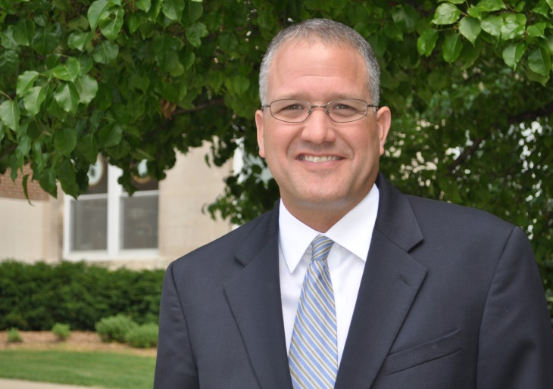
Patrick I. Cudney
MSU Extension
Associate Director for Operations

Patrick I. Cudney began serving as associate director for operations of Michigan State University (MSU) Extension on September 1, 2014. He can be relied upon to provide consistent, engaged leadership with a forward-thinking, team-centered approach. He oversees logistical and business operations, including supervising the field-based leadership team as well as providing leadership for the organizational development units of MSU Extension including budget planning and management, human resources, professional development, communications and marketing, program reporting and evaluation, diversity, technology and other essential program support.

Mr. Cudney has held a variety of progressively more responsible positions throughout his career with MSU Extension beginning in 1996 when he served as a 4-H youth agent. He quickly moved up the ranks to become, at age 27, the youngest county Extension director in the state. Three years later, he was appointed as the regional director of the MSU Extension north region. In this role, he helped direct the work of more than 150 Extension and county faculty and staff members in a 21-county region encompassing northern lower Michigan. Following the restructuring of MSU Extension in July 2010, Mr. Cudney assumed the role of district coordinator, serving nine counties in northwest lower Michigan. He remained in this role until his promotion to associate director.

Mr. Cudney holds a bachelor’s degree in community recreation and park administration from Central Michigan University and a Master of Science degree in administration from that same institution. His direct areas of interest and expertise include community engagement in public-policy decision-making and the science of public administration. He is a member of Epsilon Sigma Phi (ESP), the Extension professional’s fraternity. He participated in the North Central NELD (National Extension Leadership Development) program in 2001-02 and subsequently served on the NELD planning committee in the 2003-04 program years. He was a member of the inaugural graduating class of the LEAD21 (Leadership for the 21st Century) national land-grant leadership development program in 2005-06. His work and efforts have been acknowledged multiple times through various recognitions and awards received including the ESP Meritorious Service Award and the ESP Administrative Leadership Award.

Mr. Cudney is putting his extensive years of Extension and outreach experience to work to help foster collaborations committed to serving the needs of Michigan’s individuals, families, businesses and communities.

Patrick and his wife, Abigail, have three children, McKenna, John Patrick and Kate.

~~~~~

