Youth Business Guide to Success
Make the Most of Your 4-H Market Animal Project Workshop

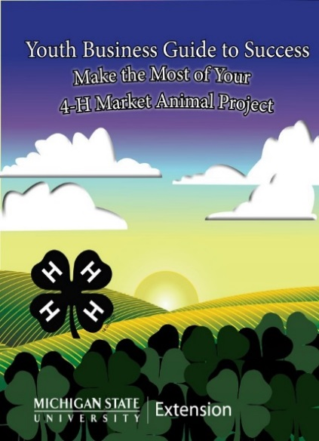
Friday, February 9, 2018
6 PM - 8 pm

WHO SHOULD ATTEND?
- 4-H livestock members ages 9 and up
- 4-H members interested in future livestock projects
- Parents and 4-H leaders
Houghton- Keweenaw
County MSU Extension Office

SISU Room

1500 Birch Street
Hancock, MI 49930

Learn about the business and entrepreneurial aspects of your livestock project.

Workshop will include:
- Determining Your Break Even
- Budgeting for Your Project Costs
- Developing a Marketing Plan
- Goal Setting

TO REGISTER
Please contact the Houghton-Keweenaw County 4-H Office
at 906-482-5830 or adoracat@anr.msu.edu
Registration deadline is Friday, February 2nd

CONTACT:
Dave Radloff Anne Kretschmann
Extension Educator Houghton-Keweenaw County
906-786-3032 4-H Program Coordinator
radloff@msu.edu 906-482-5830 kretsc11@anr.msu.edu
SPONSORS:
This training is provided in part with a grant provided by Chemical Bank and support from the Houghton-Keweenaw County 4-H Council.
MSU is an affirmative-action, equal-opportunity employer, committed to achieving excellence through a diverse workforce and inclusive culture that encourages all people to reach their full potential. Michigan State University Extension programs and materials are open to all without regard to race, color, national origin, gender, gender identity, religion, age, height, weight, disability, political beliefs, sexual orientation, marital status, family status or veteran status. Persons with disabilities have the right to request and receive reasonable accommodations.

Registration fee-
No charge for registered 4-H members
$5 per person for non-4-H members

